

__________________________________________________________

**RHODES UNIVERSITY SUSTAINABLE LAND MANAGEMENT FOR RURAL RESILIENCE PROJECT (RU-SLMRR), GEF5**

**QUARTERLY PROGRESS REPORT**

______________________________________________________________

**Report compiled by**: Dugal Harris

**Organization**:

**Quarter and year**: 042017

**Reporting outputs**: 3.1b

**Date of report:** 11122017

__________________________________________________________________________________

# INSTRUCTIONS

# Please refer to Sections A-E below and include the necessary information and attachments to document your progress toward one or more outputs of the GEF5 SLMRR Project (use the examples provided to guide you).

# Please submit your completed progress report on or before the 12th day of the final month of a particular quarter. This is according to reporting regulations set by Department of Environmental Affairs for the GEF5 SLM Project.

# Please submit your report to: Rebecca Powell (rebeccajoub@gmail.com) and cc James Gambiza (j.gambiza@ru.ac.za).

# SECTION A: OUTPUTS PROGRESS & CHALLENGES (Please complete columns A-F in the table below)

**\***Progress toward achieving planned activities indicated in column C.

**\*\*** Challenges to achieving progress on activities, as identified in columns C and D

| AOutput code | BYR1 goals (deliverables) | CPlanned activities for reporting quarter | DProgress*1 = completed, no concerns; 0.5 = partial progress, some concerns; 0 = no progress, major concerns | EChallenges** | FAddressing challenges |
| --- | --- | --- | --- | --- | --- |
| 3.1b | Report on the development of a new carbon methodology for Spekboomveld rehabilitation projects and applicability to these kinds of projects | 1) Acquire, rectify and calibrate NGI aerial imagery of study areas.2) Generate custom high resolution, high accuracy DEM of study areas for accurate orthorectificaction.3) Literature survey of using stereo aerial imagery for vegetation height derivation.4) Establish regression accuracy using 2005 CS GT and new orthorectified Quickbird image.5) Analyse field trial allometric data for informing modifications to sampling methodology.6) Assist in design of field carbon sampling methodology.7) Generate study area stratification maps and sampling plot locations. | 1) 12) 13) 14) 0.55) 16) 17) 0.5 | 1) NGI IR band georeferencing and availability problems.2) DEM anomalies in homogenous areas like dams and fields.4) Accurate location information for 2005 CS GT plots is not available. This limits the usefulness of this data for remote sensing. Specifically, poor regression accuracies could not be improved on.5) Not all species have allometric models.7) Travel time between plots can be improved. Boundaries for Tchnuganu farm were incorrect. | 1) Separate IR images were obtained from NGI. The IR bands were then stacked with the existing RGB images (after correcting georeferencing) and orthorectified using aero-triangulation data from NGI.2) It was established that the GEF sampling areas exist outside of problem DEM zones.4) It is unlikely that further work on 2005 CS GT will prove to be useful. A new regression analysis should be conducted on accurately located GEF sampling data with Worldview imagery in 2018.5) Species without models were grouped into guilds with known species.7) Sampling plot locations should be updated with correct farm boundaries. Plot clustering should be investigated as an option to decrease travel time. |

# SECTION B: IDENTIFIED RISKS AND SOLUTIONS

# Describe the identified risks to the project outputs

# *There are currently no risks to completing the initial carbon stock mapping feasibility study this year as planned. However there are factors that could result in inaccurate mapping and or inconclusive results:*

# *The poor accuracy of the Digital Elevation Model (DEM) degrades the accuracy of the satellite image orthorectification. This in turn will likely negatively affect carbon stock mapping accuracy for the feasibility study.*

# *The lack of precise corner co-ordinates for the 2005 carbon stock ground truth plots means that there is uncertainty in the location of these plots in the satellite image. This uncertainty will likely have a negative impact on the accuracy of the carbon stock mapping and could make feasibility study results inconclusive.*

# Describe possible solutions to identified risks

# *Construct a high accuracy DEM using stereo aerial imagery from National Geo-spatial Information (NGI). (This imagery has now been requested.) Alternatively, use the free 30m SRTM DEM which does improve on the existing DEM.*

# *The corner co-ordinates have been requested from Mike Powell.*

# SECTION C: SUMMARY OF LESSONS LEARNT DURING THE REPORTING QUARTER

# *Achieving adequate geometric accuracy for plot location in rugged terrain is challenging and requires both a high resolution, accurate DEM and a set of sub-meter accuracy GCP’s for orthorectification.*

# *Larger carbon stock plot size decreases sensitivity to geolocation errors, reduces variation amongst plots and facilitates more accurate carbon stock mapping.*

# SECTION D: BUDGET TRACKING

# Please note that you will be required to submit a financial report at the end of 2017 (Before December) detailing your expenditure for the year. This requires that you keep a record of all invoices and receipts relating to project expenditure. The format for the report will be sent closer to the time.

**SECTION E: APPENDICES**

**APPENDIX 1:**

*See attached document “Literature Review.docx” for a summary of the literature survey of techniques for vegetation and biomass mapping using multispectral imagery.*

**APPENDIX 2:**

Figure 1 *shows a colour-infrared rendering of the orthorectified Quickbird image covering the Baviaanskloof 2005 CS GT area. The carbon stock plots as well as collected GCP’s are indicated on the map.*

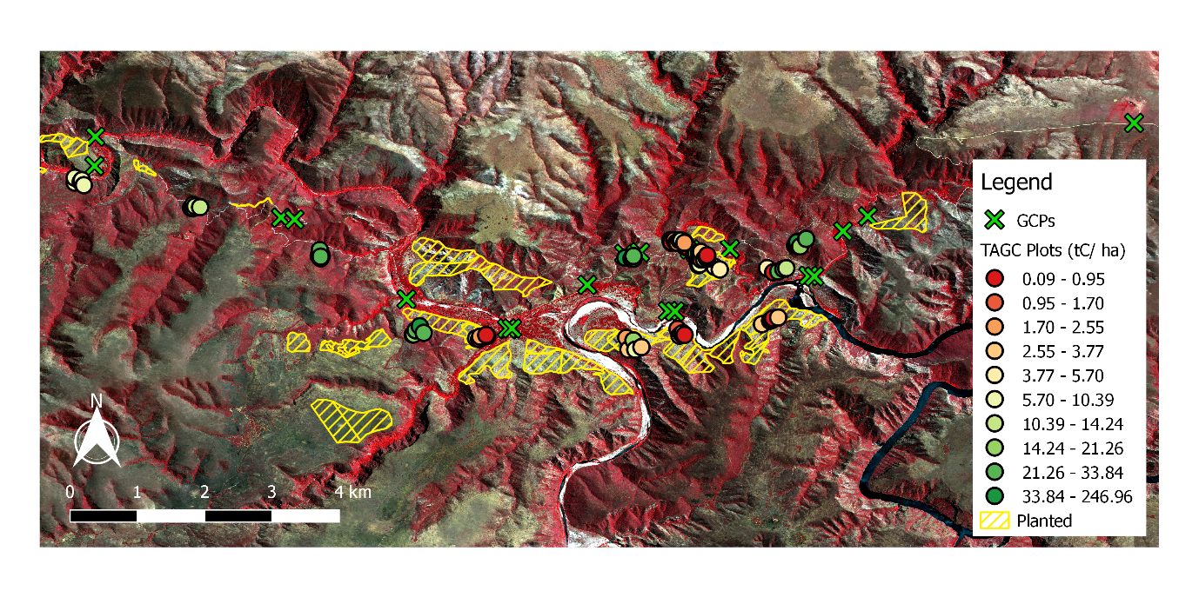Figure 1 Map of 2005 CS GT Area

**APPENDIX 3:**

*A preliminary regression analysis was conducted using the 2005 CS GT and the orthorectified and atmospherically corrected Quickbird image. The best correlation was found between log(TAGC) and NDVI, with an R2 of 0.44. A scatter plot for these values is shown in Figure 2 using image thumbnails of the plot extents. While low R2 values such as this are not uncommon in the remote sensing literature, this result is preliminary and there are a number of possibilities for improvement. These include addressing the concerns raised in Section B as well as investigating the use of more sophisticated image features and regression models. It may also be possible to extract a crude measurement of vegetation height or volume from the NGI stereo aerial imagery. This would be a useful feature for the regression model.*

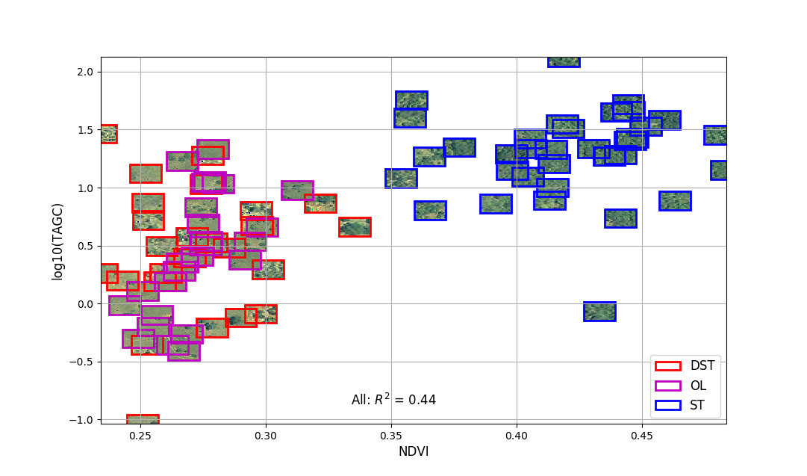

Figure 2 Correlation between log(TAGC) and NDVI

**APPENDIX 4**

*The effect of increased plot size on the strength of correlation between derived image measurements and carbon stock ground truth was simulated using the 2005 CS GT. Larger plot sizes were simulated by combining data for multiple plots into one pseudo-plot. Plots were only combined with other plots belonging to the same degradation class. The degradation classes were OL = “old lands”, DST = “degraded subtropical thicket” and ST = “intact subtropical thicket”. The original plot sizes were 5x5m for DST and ST, and 25x25m for OL. R2 values were found for the relation between log(TAGC) and NDVI for the combined plots. Results are shown in* Figure 2*. These results are relevant for the selection of plot size for the GEF carbon stock inventory and imply that there are significant improvements to be gained from using larger plot sizes. The simulation is crude however and the R2 values should not be taken as indicative of what will be achieved in the GEF5 study area.*

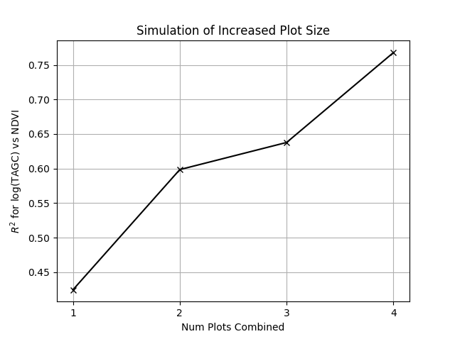

Figure 3 Simulation of Increased Plot Size

**APPENDIX 4**

*It was found that orthorecitifacation using the 5m SUDEM (Stellenbosch University DEM) was resulting in poor geolocation accuracy. The accuracy of SUDEM was analysed by comparing heights to the DGPS acquired heights at the GCP points. A similar comparison was made with the 30m SRTM DEM. The SRTM DEM was found to improve on the accuracy of SUDEM. Results are shown in Figure 4.*

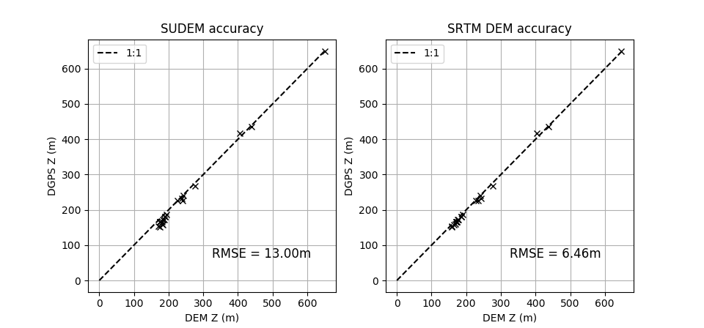

Figure 4 DEM accuracy analysis